KAMPALA JUNIOR ACADEMY SCHOOLS
PRIMARY THREE LITERACY I 2020
1. Give one characteristic of living things.
2. Why do animals move from one place to another?
3. What is the use of spiracles to an insect?
4. Why is rain important to farmers?
5. How does a chameleon protect itself?
6. Name the main natural source of water.
7. Which clouds give us rain?
8. Give one example of a domestic bird.
9. What are wild animals?
10. What name is given to a house of a bird.
11. Name the part marked A.
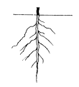
A
12. Mention the instrument used to measure the amount of rainfall in a place.
13. Identify one component of air.
14. Apart from drying our clothes, give any other use of wind to people.
15. Give one reason why the sun can be dangerous to people.
16. Which type of soil is good for growing crops?
17. Name one thing used for cleaning our hands after the toilet.
18. 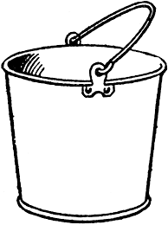 Name this container used for fetching water.
19. Which type of accident is most likely to happen to you if you play with fire.
20. Mention one type of weather.
21. Give one use of water at home.
22. Give one reason why we give first aid.
23. Why are bees important?
24. At what time of the day does the shadow appear short?
25. Name one natural source of light.
26. Which type of air do people breathe in?
27. Give one danger of wind.
28. Which type of air is used to preserve soft drinks like sodas.
29. What property of air is shown below.
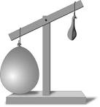
30. Name one agent of soil erosion.
31. Mention any one layer of soil.
32. What is a forest?
33. Give one thing made out of timber.
34. Give one way we can keep our environment clean.
35. Identify any component of environment.
36. What are natural changes?
37. Name one example of a natural change.
38. Give one use of soil to people.
39. Mention any common diseases.
40. Why do we boil drinking water?

SECTION B
41a) What is the main natural source of water.
b) Name any two human made sources of water.
c) Give one domestic use of water.
42a) Give one product got from the following.
a) milk
b) animal skins
c) banana fibre
d) clay
43. The diagram below shows a plant, use it to answer the questions that follow.
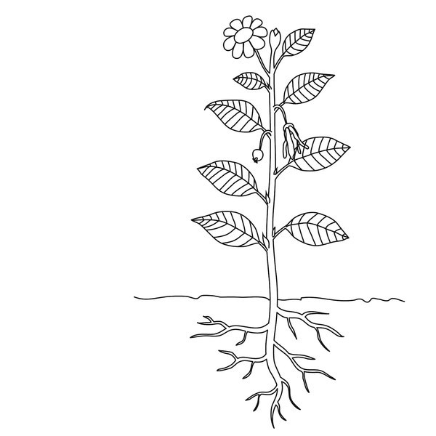
C
D
B
A
a) Name parts marked:-
(i)A_________________
(ii)C________________
(iii)D________________
b) Give one use of part B to people.

44a) Give the meaning of the term environment.
b) Write down any three components of environment.
c) State one activity done by people to spoil the environment.
45a) Write down any two ways of caring for plants.
b) Name the garden tools used by farmers to do the following.
a) digging____________________ b) transplanting seedlings___________
46a) Draw these items used for keeping proper sanitation.
broom | mop | water

b) Why should we keep proper sanitation?
47. What is air?
b) Give any two gases of air.
c) State one property of air
48a) State the importance of keeping our bodies clean.
b) Name any three items used for keeping the body clean.
49.The diagram below is of a living thing. Use it to answer the questions that follow.
a) Name the animal above
b) How does the animal above move?
c) Why does the animal above move?
d) State one danger of the animal above.

50a) Match and re-write food with food values.
cassava | proteins
fish | vitamins
oranges | carbohydrates

b) Why do we eat food?
51a) What are living things?
b) Give the two main groups of living things.
c) Name one one-living things.
52a) The diagram below is of the soil profile. Use it to answer the questions that follow.
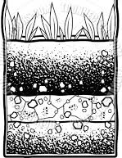
C
B
A
a) Name the layers marked
(i)B_________________
(ii)C________________
b) How is layer marked A important to farmers?
c) In which layer does weathering of rocks take place?

53a) Write down any two examples of insects.
b) How many legs does an insect have?
c) What does an insect breathe through?
54a) What are domestic animals?
b) Name any two domestic animals you know.
c) Why do people keep domestic animals.
55a) What do we call the sudden happening that causes injury for the body?
b) Draw these things used for first aid.
Gloves | bandage | plaster
Project Work
With the help of your parent/guardian, make a rain cycle process.
Materials
-cotton wool
-manilla
-food colour
-straw,etc
Present it on the reporting day.
Reference books
-Kobta Literacy bk 3
-MK Literacybk 3 (Thematic Curriculum)

