DISNEY KINDERGARTEN AND PRIMARY SCHOOL
P.2 I.R. E HOMEWORK FOR WEEK 4 AND 5 2020

NAME: ____________________________________________________________
DAY ONE
- What do we call a group of people related by blood, marriage or adoption?
__________________________________________________________
2. Write three people found in our family.
I)___________________II) ______________III)_________________
3. Draw these non- living things created by Allah.
lake | hills | stones and rocks
4. Why do you go to the hospital?
_____________________________________________________
5. How can you show respect to your neighbour in class?
i) _________________________________________________________
ii) _________________________________________________________
6. Mention two religious leaders of Islam.
i)___________________________ ii)_________________________
7. Draw these symbols of Islam.
Moon and a star | Tasbir
8. Write any two things used in a Mosque
I) ____________________ II)_____________________
9. Give the meaning of the following:
a) Allah Ak’baru - _____________________________________
b) HaiayaAllalFalah - __________________________________
DAY TWO
1. Name the holy book for Muslims.
___________________________________________________________
b). Why do you read the above book?
___________________________________________________________
2. Write two ways of communicating to Allah;
I) _________________________________________________________
II)_________________________________________________________
3. Write any two needy people Muslims help.
I)________________________ II)_______________________________
4. Why do we have these things in a Mosque?
a) Pulpit - ________________________________________________
b) Curtains _ _____________________________________________
5. Write any two Muslim names for boys and girls.
- Boys ____________________, __________________
- Girls ___________________, __________________
7. Who is a prophet?
__________________________________________________________
b) Why is Prophet Muhammad important to Muslims?
_________________________________________________________
8. Give any two examples of good behaviour practised by a Muslim child.
a) _________________________________________________________
b)__________________________________________________________
9. Mention any two groups of people who are not allowed to fast.
a) ____________________________ b) _______________________
10. Use the words below to complete correctly.
Sheikh, Muslims, mosque, Friday, heads

A ___________________ is the holy place of prayers for______________. They go to the mosque every ___________ for general prayers. The ________________ guides the Muslims on how to practice Islam religion. A Mufti ________________ the Muslim community in a country and a muezzin calls Muslims for prayers.
DAY THREE
1. What is a prayer? ___________________________________________________________
2. Muslims pray _____________times in a day.
3. Match correctly.
Subhi is a prayer performed in the afternoon
Ishai it is a performed during sun set.
Magarib it is performed at night.
Aswir it is performed in the evening
Shuhuri it is performed early in the morning
6. Name these animals created by Allah.
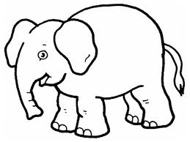
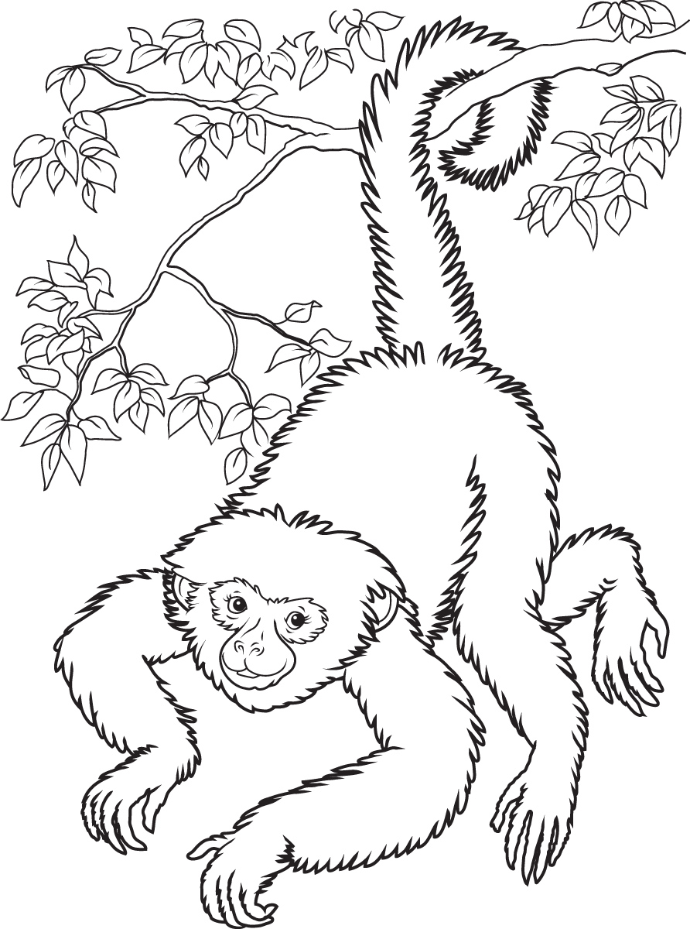

7. Name the angel who brings messages to prophets.
__________________________________________________________
8. Mention any two bad acts that can lead people to go to Jahannam.
a)__________________________________________________________
b) __________________________________________________________

9. ____________________ is the money or material which Muslims give to Allah in the mosque.

10. Write in full
PBUH - __________________________________________________

