DISNEY KINDERGARTEN AND PRIMARY SCHOOL
P.2 CHRISTIAN RELIGIOUS EDUCATION TERM I 2020

NAME: _____________________________________________________
DAY 1
1. What do we call a group of people related by blood, marriage or adoption?
________________________________________
2. Write three people found in our family.
i) _______________________ (ii) ___________________
(iii) _____________________________________________
3. Draw these non- living things God created.
lake | hills | stones and rocks

4. Write your religious name.
_________________________________________________________

5. Why do you go to the hospital?
______________________________________________________
6. How can you show respect to your neighbour in class? (Give two ways)
i) ______________________________________________________
ii) _____________________________________________________
7. Mention two things you learn from the story of a good Samaritan.
i) _____________________________________________________
ii) _____________________________________________________
8. Mention two Religious leaders for Christians.
i) _____________________________________________________
ii) ______________________________________________________
9. Draw these symbols of Christianity.
rosary | cross

10. Write any two things used in the Church or Temple.
i) ___________________ ii)_____________________
11. Why did Jesus die on the Cross?
_________________________________________________________
12. Write any two miracles performed by Jesus.
- _____________________________________________________
- _____________________________________________________
DAY 2
1. Name the holy book for Christians.
_______________________________________________________
2. Give the meaning of these names.
a) Irene - ___________________________________________________
b) Peter - ___________________________________________________
c) Emmanuel - ______________________________________________
3. Why do we have church leaders in our community?
(Give two reasons)
i) ____________________________________________________________
ii) ___________________________________________________________
4. Write two ways of communicating to God;
i) ____________________________________________________________
ii) ___________________________________________________________
5. Name these items used during baptism.
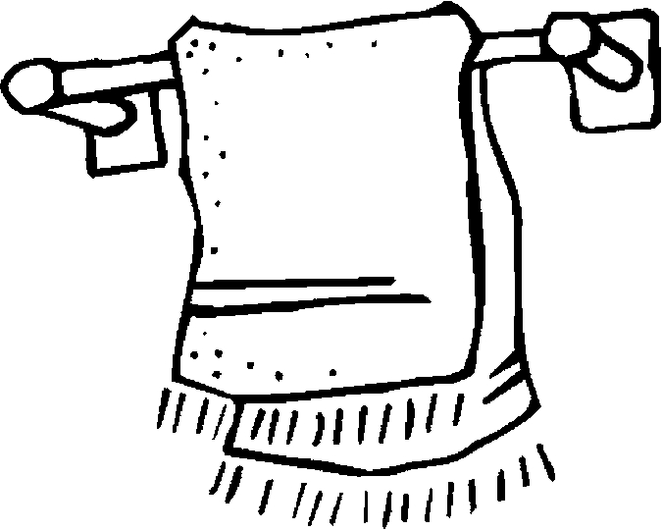 | 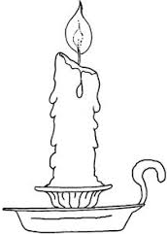
6. Name any two apostles of Jesus.
i) ________________________ii) ________________________
7 a) Name any two needy people in our community.
___________________________ _____________________________
b). Draw a P.2 child helping a needy person.

8. Why do Christians read the Bible?
_________________________________________________________
9.Write any two Christian names for boys and girls.
Boys ______________________, _______________________
Girls ______________________, _______________________
10. Write two ways of showing respect to adults?
I)______________________________________________________
II) _____________________________________________________
10. Match correctly
tongue for feeling
skin for hearing
nose for tasting
ears for smelling

- tongue ____________________________________________________
- skin _______________________________________________________
- nose ______________________________________________________
- ears _______________________________________________________
11. What did God create on the third day?
______________________________________________________________
DAY 3
1. What is a prayer? ____________________________________________________________________________________________________________________________
2. Write two places of worship you know.
i)____________________________ (ii) _________________________
5. Write any two books in the New Testament.
I) _______________________ II) ____________________________
6. Name these animals created by God.
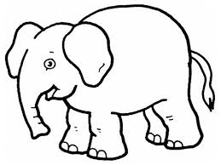
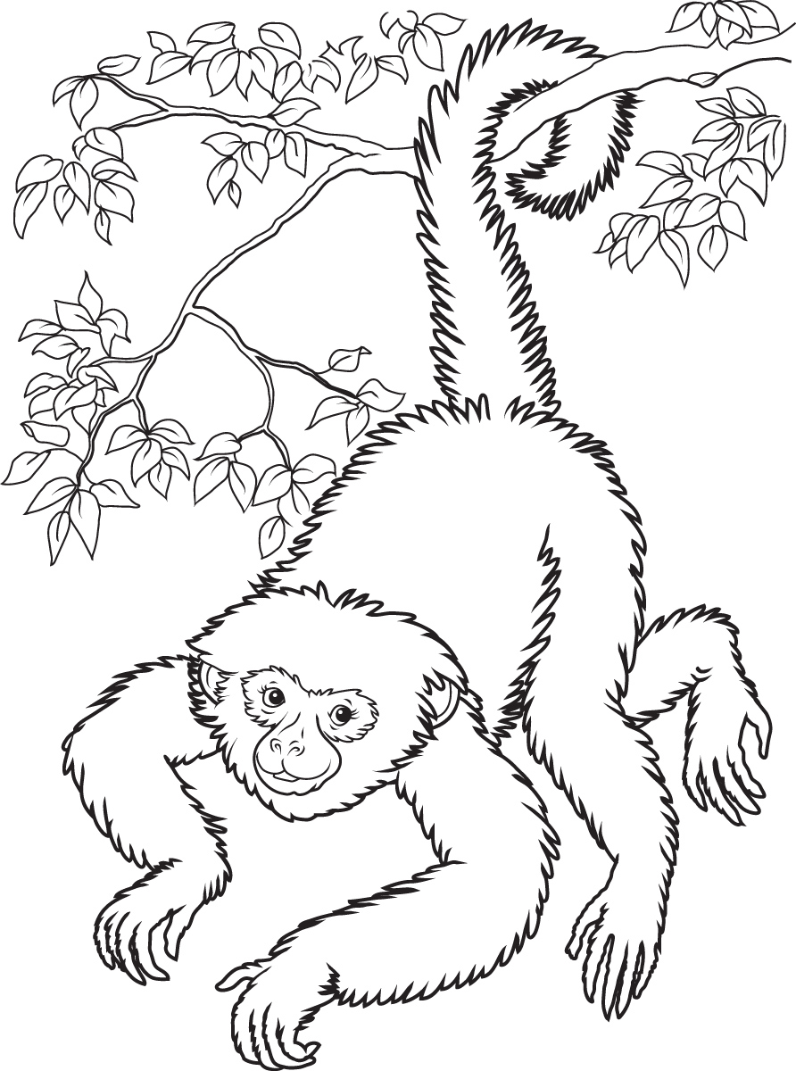

7. According to Matthew 3: 17
“Then a voice said from heaven, this is my own dear son,
with whom I am pleased”

a) Who said the above words?
______________________________________________________________
b) Where was Jesus Christ baptised?
______________________________________________________________
c) In which form did the Holy Spirit appear?
______________________________________________________________
d) Who baptised Jesus?
______________________________________________________________
- Read the book of Psalm 23.
What have you learnt from the reading? __________________________________________________________________________________________________________________________________________________________________________________________

