P.5 SOCIAL STUDIES REVISION EXERCISE

SECTION A:
- What is the difference between a map and a picture?
- State one similarity between a map and a picture.
- Give the problem a map reader will face when he/she reads a map without a scale.
- Draw a map symbol of a mountain.
- State any one reason why a map should have map symbols.
- What is a sketch map?
- Give any one way Uganda is related to Rwanda in terms of location.
- Name any two lakes in Uganda which are crossed by the equator.
- Why is Uganda called a land locked country?
- Mention the economic importance of Kenya to Uganda.
- Give any two land locked countries which neighbor Uganda.
- Name the main line of longitude which determines international days and dates.
- What is equinox?
- Mention the two months when the sun is overhead the equator.
- Name the lines of latitude marked A, B, C and D.

66½⁰N
A

B

C

D
E

23½⁰N

0⁰

23½0S

66½⁰S

- Study the table below and answer the questions that follow.
Mountain | Ways of formation | Highest peak
Elgon |  | Wagagai
 | Volcanicity | Sokdek
Rwenzori | Faulting
 | Volcanicity | Muhavura

- State any two problems faced by people who stay near mountains.
- Name any two parts of river Nile found in Uganda.
- Mention any two examples of island districts of Uganda found in Lake Victoria.
- Study the map below and answer the questions that follow.
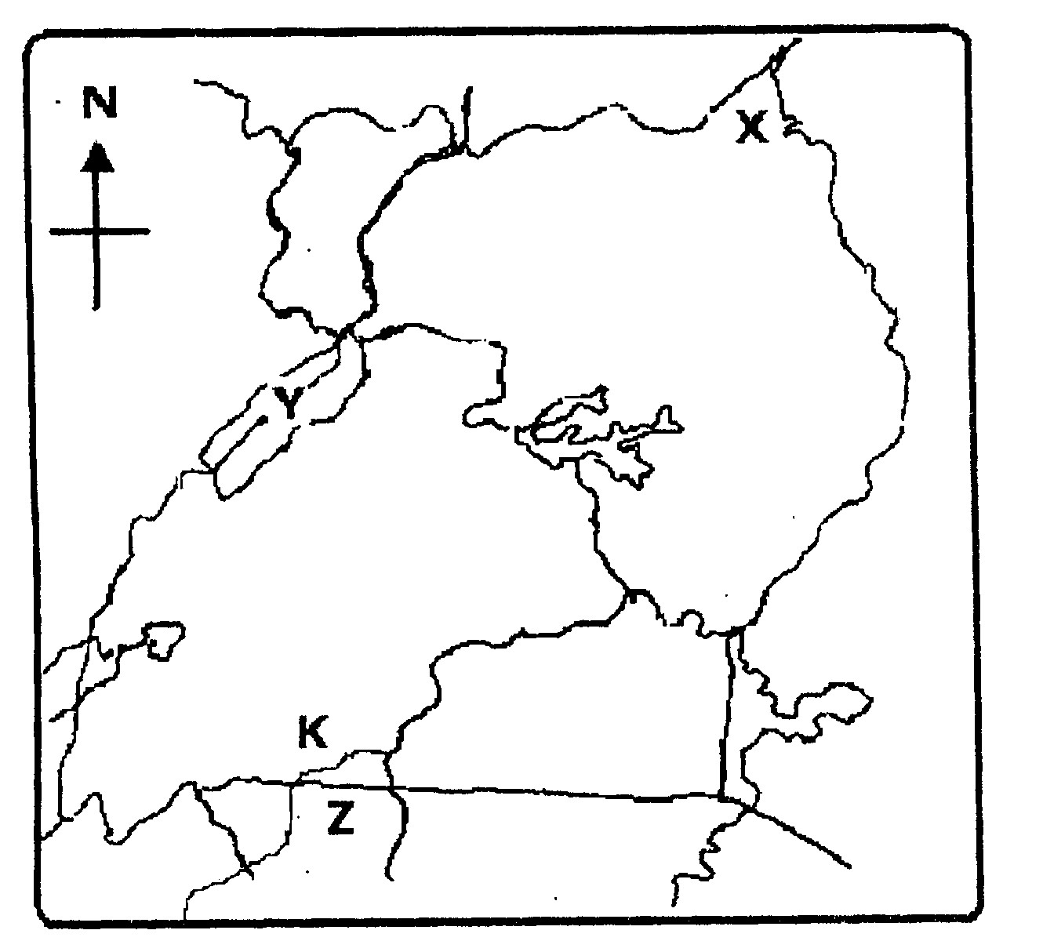
B

L

C
P
E
D
20.a) Name the physical features marked P, B, C and D.
- Name the water channel marked L.
- Give one reason why lake marked B is swampy.
- Mention any one force which helped in the formation of Mt. Rwenzori and the western rift valley.
- State any one political importance of physical features.
- What evidence shows that Lake Victoria is on a higher altitude than Lake Kyoga?
- What is altitude?
- Name the instrument used to measure altitude.
- What is vegetation?
- Name any two types of vegetation. 28. What type of wood is got from;
- Planted forests?
- Natural forests?
29. Write the following in full
- NEMA
- UWEC iii) UWA iv) NFA
- Name the type of natural vegetation which covers the largest part of Uganda.
- State any two problems faced by vegetation in Uganda.
- Mention any two ways man can destroy vegetation.
- Give any two reasons why man destroys vegetation.
- Name the largest natural forest in Uganda.
- State any three ways man can care for vegetation.
- What are social services?
- State any two examples of social services.
- Give any two ways people care for social service centres.
- Suggest one way the sudden outbreak of an epidemic disease like Ebola, Cholera, COVID 19, can hinder the development of a country.
- State any two ways UNRA promotes better transport network in Uganda.
- Mention any two means of air transport.
- Give any two sources of electricity in Uganda.
- What is recreation?
- State any two reasons why some people in Uganda fail to meet their basic needs.

- Match correctly.
Teacher cares for sick people
Nurse receive money and cheques in a bank
Veterinary officer teaches learners (pupils and students)
Bankers treats sick domestic animals
- Name the first person to be created by God.
- According to the Bible, who was the first murderer?
- Name any two sons of Adam and Eve.
- Write down any four pillars of Islam.
- What is faith?
- Give any two people in the Bible and the Qur’an who demonstrated strong faith in God or Allah. 52. Mention the Holy book for
i) Christians ii) Muslims
- Name any two examples of people who accepted to respond to Jesus’ call to follow Him.
- Mention any two examples of archangels in the Bible.
- Give any three examples of prophets in the Qur’an.

