TWALIBAH ISLAMIC PRIMARY SCHOOL
PLE MOCK EXAMINATION 2019
PRIMARY SEVEN
BASIC SCIENCE AND HEALTH EDUCATION
Time allowed: 2 hours 15 minutes

Index No.

Candidate’s Name: ____________________________________________________
Candidate’s Signature: _________________________________________________
School Name: ________________________________________________________
Read the following instructions carefully:
- The paper has two sections: A and B
- Section A has 40 questions (40 marks)
- Section B has 15 questions (60 marks)
- Answer ALL questions. All answers to both Sections A
and B must be written in the spaces provided.
- All answers must be written using a blue or black ball
point pen or ink. Diagrams should be drawn in pencil.
- Unnecessary crossing of work may lead to loss of marks.
- Any handwriting that cannot be easily read may lead to
loss of marks.
- Do not fill anything in the boxes indicated;
For Examiner’s use only.

Turn over

SECTION A: 40 MARKS
Questions 1 to 40 carry one mark each
1. Give any one example of fungi.
_______________________________________________________________________
2. What name is given to the darkest part of a shadow?
_______________________________________________________________________
3. What is meant by soil erosion?
_______________________________________________________________________
_______________________________________________________________________
4. How can a farmer prevent rusting of his garden tools?
_______________________________________________________________________
5. Name the mineral salt that helps in the strengthening of our teeth and bones.
_______________________________________________________________________
6. Mention one reason why some plants climb others.
_______________________________________________________________________
7. Why is it not good to cut down trees without planting new ones?
_______________________________________________________________________
_______________________________________________________________________
8. Give any one way in which plant leaves are important to people, apart from eating them.
_______________________________________________________________________
9. Mention any one cause of dental disorders.
_______________________________________________________________________
10. In the space below, draw the head of a tape worm and show the suckers.

11. What happens to a piece of cheese which is left outside on a sunny day?
_______________________________________________________________________
12. State any one function of the skull in a human body.
_______________________________________________________________________
_______________________________________________________________________
13. Give any one reason why a chameleon changes its colour according to the environment.
_______________________________________________________________________

14. Why do we iron clothes?
_______________________________________________________________________
15. Mention one reason why farmers sow seeds in the wet season.
_______________________________________________________________________
_______________________________________________________________________
16. Name the part that protects the inner parts of a fish from damage.
_______________________________________________________________________
17. Fill in the missing word to complete the life cycle of a cockroach below.
Egg

Adult

18. Mention any one disease which a home without a latrine can suffer from.
_______________________________________________________________________
19. What is a hutch?
_______________________________________________________________________
_______________________________________________________________________
The diagram below shows roots of a legume. Study it carefully and answer question 20.
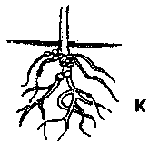

20. Name the living organisms found in the structures marked with letter K.
_______________________________________________________________________
21. Name the part of a flower which protects the ovules.
_______________________________________________________________________
22. Why is bush burning as a method of clearing land discouraged?
_______________________________________________________________________
23. What role does the sun play in the process of rain formation?
_______________________________________________________________________
24. Which body part is cleaned by using a pumice stone?
_______________________________________________________________________
25. Mention any one source of Vitamin A.
_______________________________________________________________________
26. Why does water go through sandy soil faster than clay soil?
_______________________________________________________________________
_______________________________________________________________________
27. Which first aid would you give to someone who has got a scald?
_______________________________________________________________________
_______________________________________________________________________
28. Write down one breed of goats reared in Uganda.
_______________________________________________________________________
29. Why is it important to maintain a good body posture?
_______________________________________________________________________
_______________________________________________________________________
Below is the picture of an animal. Study it and answer question 30.
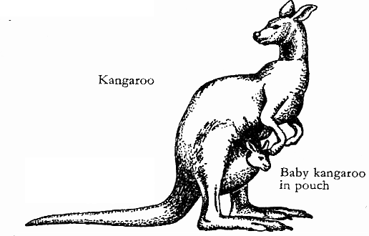

30. To which group of vertebrates does the animal above belong?
_______________________________________________________________________
31. Why would you regard water snails as vectors?
_______________________________________________________________________
32. Name the digestive juice which is added to food in the mouth.
_______________________________________________________________________
33. Why are honey bees called social insects?
_______________________________________________________________________
34. Give one use of friction to man.
_______________________________________________________________________
35. Give any one economic use of cattle.
_______________________________________________________________________
36. Which element of Primary Health Care helps to control rapid population growth?
_______________________________________________________________________
The diagram below shows two similar flowers. Study it carefully and answer questions 37
and 38.

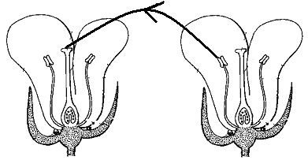

37. Name the type of pollination is shown above.
_______________________________________________________________________
38. Name part marked Z in the diagram shown above.
_______________________________________________________________________
39. How is a strain different from a sprain?
_______________________________________________________________________
_______________________________________________________________________
40. Calculate the effort needed to raise a load of 25Kg. using the machine shown below.
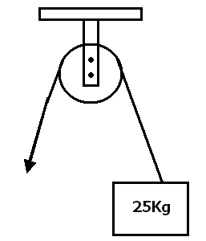

SECTION B
Questions 41 to 55 carry four marks each.
41. The diagram below shows three different types of teeth. Use it to answer the questions that follow.
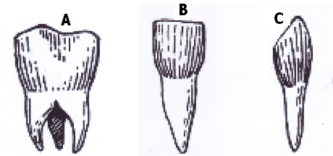

(a) Name the tooth marked A.
____________________________________________________________________
(b) State the function of tooth marked C.
____________________________________________________________________
(c) How is tooth marked B adapted to its function?
____________________________________________________________________
____________________________________________________________________
(d) How many teeth should a normal adult person have?
____________________________________________________________________

42. (a) Write O.R.S in full.
_________________________________________________________________
(b) Give any two of the items used in making O.R.S
(i) _________________________________________________________________
(ii) _________________________________________________________________
(c) Why is O.R.S given to patients with vomiting and diarrhoea?
_________________________________________________________________
_________________________________________________________________

43. (a) What is meant by mulching?
_________________________________________________________________
_________________________________________________________________
(b) Mention any three reasons why farmers mulch their gardens.
(i) _________________________________________________________________
(ii) _________________________________________________________________
(iii) _________________________________________________________________
44. The diagram below shows fertilization in a human being. Use it to answer questions that follow.
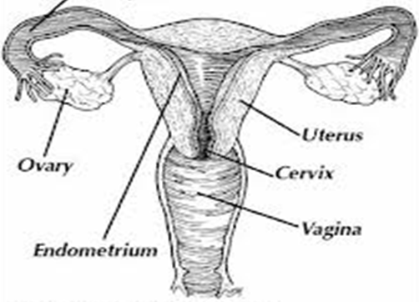

(a) Name the parts marked X and Y.
(i) X ________________________________________________________________
(ii) Y ________________________________________________________________
(b) What will happen if the sperms do not reach the fallopian tube?
_________________________________________________________________
(c) Why is part Z important in the process of fertilization?
_________________________________________________________________
45. Match the vectors in list A with the diseases they spread in list B.
A B
Water snail malaria
Housefly trachoma
Anopheles mosquito rabies
Mad dogs bilharzia
(i) Water snail ________________________________________________________
(ii) Housefly _______________________________________________________
(iii) Anopheles mosquito _________________________________________________
(iv) Mad dogs _________________________________________________________

46. (a) Name the gas found in fire extinguishers.
_________________________________________________________________
(b) Why was the gas named above chosen to be used in fire extinguishers?
_________________________________________________________________
(c) Give the danger of the above mentioned gas in our environment.
_________________________________________________________________
(d) Suggest one way of controlling the gas above in our environment.
________________________________________________________________

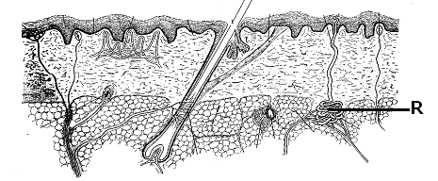
47. The diagram below is of a human skin. Use it to answer the questions that follow.

(a) To which body system does the organ in the diagram belong?
_____________________________________________________________________
(b) Name part marked R.
_____________________________________________________________________
(c) Mention any one function of the organ shown in the diagram.
_____________________________________________________________________
(d) Give one way of keeping the organ in a healthy and good condition.
_____________________________________________________________________

48. (a) What is environmental degradation? _________________________________________________________________
_________________________________________________________________
(b) Mention any two causes of environmental degradation.
(i) _________________________________________________________________
(ii) _________________________________________________________________
(c) Suggest one way of conserving forests.
_________________________________________________________________
49. Mulokole kept one goat and one rabbit in different houses. He used to put different types of food in their houses. He recorded the number of times they ate each food. The following was his daily record:
Animal | Number of times each food was eaten
 | Sweet potato leaves | Cassava leaves | Sorghum leaves | Grass | Maize leaves | Banana leaves
Goat | 3 | 1 | 0 | 3 | 2 | 4
Rabbit | 4 | 2 | 1 | 2 | 3 | 2

(a) What was the most favourable food for the:
(i) goat? ____________________________________________________________
(ii) rabbit? ___________________________________________________________
(b) What was the least favourable food for the rabbit?
_________________________________________________________________
(c) If Mulokole were to use only one type of food, which one would be the most favourable for both the goat and the rabbit? _________________________________________________________________
50. (a) Write down any one crop that can be destroyed by rodents in a farmer’s garden.
_________________________________________________________________
(b) State the difference between a pest and a vector.
_________________________________________________________________
_________________________________________________________________
(c) Suggest any two ways of protecting crops from being destroyed by monkeys.
(i) _________________________________________________________________
(ii) _________________________________________________________________
51. (a) Why are young children grouped under the vulnerable groups of people?
_________________________________________________________________
(b) Apart from the young children, name two other vulnerable groups of people.
(i) _________________________________________________________________
(ii) _________________________________________________________________
(c) Why should an individual be fed on fruits?
_________________________________________________________________
52. The diagram below shows feet of different birds. Use it to answer the questions
that follow.
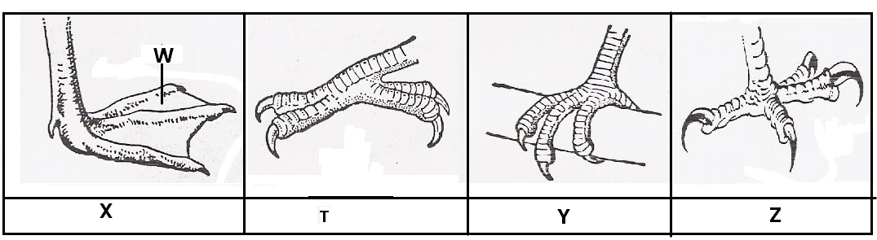

(a) Name part marked W on the foot marked X..
____________________________________________________________________
(b) What does the bird with foot marked Z fed on?
____________________________________________________________________
(c) Identify the group of birds with foot marked T.
____________________________________________________________________
(d) State one group of a bird with foot marked Y.
___________________________________________________________________

53. (a) Give any two reasons why a school going pupil should learn about the 4Fs?
(i) _________________________________________________________________
(ii) _________________________________________________________________
(b) Give any two ways we can keep our food free from germs.
(i) _________________________________________________________________
(ii) _________________________________________________________________

54. Give the use of the garden tools below.
(a) Panga ____________________________________________________________
_________________________________________________________________
(b) Rake _____________________________________________________________
_________________________________________________________________
(c) Wheelbarrow ______________________________________________________
_________________________________________________________________
(d) spade ____________________________________________________________
_________________________________________________________________

55. The diagram below is of a human heart. Use it to answer the questions that follow.
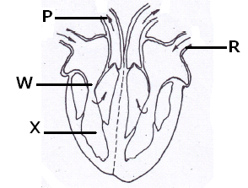

(a) Name part marked X.
___________________________________________________________________
(b) What is the function of part marked W?
_ __________________________________________________________________
(c) To which body organ does part marked P transports blood?
____________________________________________________________________
(d) Which type of blood is transported through blood vessel marked R?
_________________________________________________________________
Good luck

